MN3101 CORPORATE FINANCE / WORKING DRAFT

Portfolio diversification and shareholder value

Task 1. Stock selection and diversification
The sample contains 15 US-listed shares spanning eight sectors. Eight companies are exposed to technology through digital advertising, consumer devices or semiconductor design, fabrication and equipment. This gives the sample exposure to different stages of the technology supply chain, although several firms remain sensitive to the same investment cycle. The other seven companies broaden the economic exposures. ExxonMobil and Newmont add exposure to oil and gold, Walmart and Coca-Cola to household spending, Johnson & Johnson to healthcare demand, NextEra to electricity markets and JPMorgan to credit conditions.
I expected ASML and Lam Research to move closely together. ASML reported €24.5 billion of net system sales across logic and memory in 2025. Lam attributed part of its FY2025 revenue growth to higher customer equipment spending in memory and foundry (ASML, 2026; Lam Research, 2025). Their tools serve different fabrication processes, but a decision by chipmakers to expand or defer capacity can affect orders at both suppliers. Their Pearson correlation of 0.801, the highest of the 105 pairs, supports the expectation.
I expected NVIDIA and Walmart to move less closely. NVIDIA generated $193.7 billion of its $215.9 billion FY2026 revenue from Data Center, while Walmart U.S. recorded $285.5 billion in grocery sales (NVIDIA, 2026; Walmart, 2026). Demand for accelerated computing and demand for groceries respond to different spending decisions. The pair’s correlation of 0.221 was below the sample average of 0.267 and well below the equipment pair’s correlation. The positive correlation indicates some shared exposure.
The last trading day’s adjusted close in each month from September 2016 to September 2026 gives 121 USD prices per stock and 120 aligned monthly simple returns. For stock i, P is the adjusted closing price, t indexes the month and T = 120.
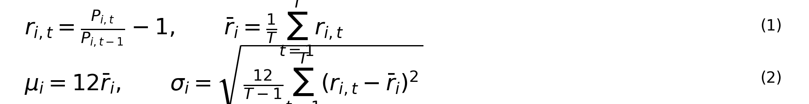

Table 1. Individual stock return and volatility
Company | Ticker | Sector | Returns | Mean (%) | SD (%)
Alphabet | GOOGL | Communication Services | 120 | 25.25 | 26.87
Meta Platforms | META | Communication Services | 120 | 24.17 | 36.42
Apple | AAPL | Information Technology | 120 | 29.42 | 27.13
NVIDIA | NVDA | Information Technology | 120 | 60.58 | 46.46
Taiwan Semiconductor (ADR) | TSM | Information Technology | 120 | 34.79 | 32.88
ASML Holding (US listing) | ASML | Information Technology | 120 | 35.13 | 34.74
Micron Technology | MU | Information Technology | 120 | 55.26 | 55.57
Lam Research | LRCX | Information Technology | 120 | 45.74 | 41.75
ExxonMobil | XOM | Energy | 120 | 14.54 | 28.39
Newmont | NEM | Materials | 120 | 19.0 | 34.29
Walmart | WMT | Consumer Staples | 120 | 18.25 | 19.17
Johnson & Johnson | JNJ | Health Care | 120 | 12.29 | 17.22
NextEra Energy | NEE | Utilities | 120 | 14.04 | 21.75
JPMorgan Chase | JPM | Financials | 120 | 21.73 | 24.34
Coca-Cola | KO | Consumer Staples | 120 | 11.58 | 16.33
Source for Tables 1–3 and Figure 1: Yahoo Finance via yfinance, split- and dividend-adjusted closes downloaded 4 November 2026. Prices run from September 2016 to September 2026. Returns run from October 2016 to September 2026. All 15 listings are in USD.

Task 2. Efficient frontiers
The annualised sample covariance between stocks i and j is given by equation (3). At each target return, I minimise portfolio variance subject to the target return, weights summing to one and individual bounds of 0% to 100% or −100% to +100%.
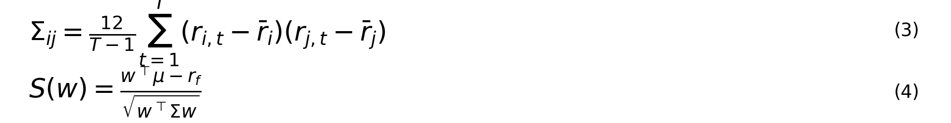
The Sharpe benchmark is the 4.21% annual bond-equivalent yield on the three-month US Treasury bill recorded in S&P Capital IQ on 3 November 2026. All portfolios hold only the 15 shares.

Figure 1. Long-only and bounded-short efficient frontiers
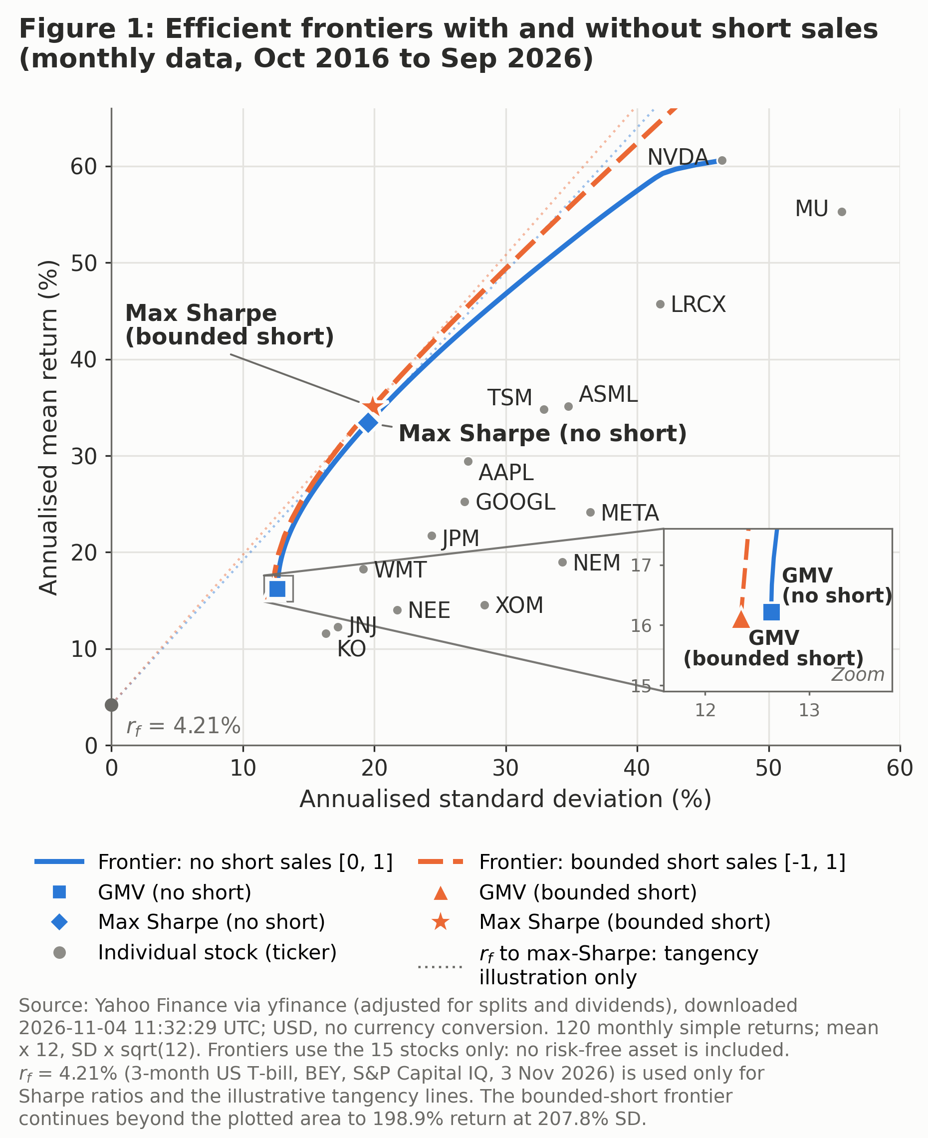

Table 2. Performance of the four portfolios
Portfolio | Annual mean (%) | Annual SD (%) | Sharpe
GMV (no short) | 16.22 | 12.64 | 0.951
Max Sharpe (no short) | 33.4 | 19.53 | 1.494
GMV (bounded short) | 16.12 | 12.34 | 0.965
Max Sharpe (bounded short) | 35.04 | 19.86 | 1.553

Table 3. Stock weights (% of portfolio value)
Ticker | GMV long-only | Max Sharpe long-only | GMV bounded | Max Sharpe bounded
GOOGL | 5.00 | 0.00 | 5.96 | -4.39
META | 2.61 | 0.00 | 2.97 | -10.21
AAPL | 1.98 | 8.08 | 1.03 | 11.08
NVDA | 0.00 | 22.07 | 1.23 | 26.55
TSM | 2.01 | 0.00 | 5.54 | 3.63
ASML | 0.00 | 0.00 | -11.35 | -22.38
MU | 0.95 | 9.94 | 4.19 | 9.51
LRCX | 0.00 | 5.09 | -1.35 | 18.90
XOM | 7.02 | 0.75 | 6.34 | -0.29
NEM | 1.72 | 11.73 | 1.29 | 13.84
WMT | 18.96 | 29.92 | 20.22 | 37.15
JNJ | 19.25 | 1.26 | 21.22 | 0.42
NEE | 12.51 | 0.00 | 13.04 | -1.78
JPM | 3.47 | 5.74 | 4.72 | 7.16
KO | 24.53 | 5.43 | 24.95 | 10.81
Sum of weights | 100.00 | 100.00 | 100.00 | 100.00
Gross exposure | 100.00 | 100.00 | 125.41 | 178.10
GMV = global minimum variance. Gross exposure sums the absolute weights. Percentages are rounded for display.

How short sales change the frontiers
Every long-only allocation remains feasible when bounded short sales are permitted. The larger set of weights therefore allows the optimiser to achieve the same target return at equal or lower volatility. The global minimum-variance portfolio’s annualised volatility falls from 12.64% to 12.34%, while its estimated return falls from 16.22% to 16.12%. The maximum-Sharpe portfolio moves to a different point on the frontier. Its return rises from 33.40% to 35.04%, while volatility rises from 19.53% to 19.86%. The increase in estimated excess return outweighs the increase in volatility, lifting the Sharpe ratio from 1.494 to 1.553.

Which holdings drive the differences
The largest weight change in the maximum-Sharpe portfolio is ASML, from zero to −22.38%, alongside an increase in Lam Research from 5.09% to 18.90%. Given their 0.801 correlation, the opposing positions partly offset shared semiconductor equipment exposure while retaining a positive position in Lam, which had the higher sample mean. ASML itself had a positive mean return of 35.13%. Its short position makes sense in relation to the other holdings and their covariances.
NVIDIA rises from 22.07% to 26.55% and Walmart from 29.92% to 37.15%. Their relatively low correlation helps explain why the optimiser can hold a substantial position in NVIDIA, whose standalone volatility was 46.46%, alongside a large Walmart allocation.

Limits for an investor
Both portfolios are selected and evaluated on the same 120 observations, so their Sharpe ratios measure in-sample performance. If NVIDIA’s sample mean of 60.58% is a poor guide to future returns, its allocation and the apparent advantage of shorting may change materially. Correlations can also shift as business exposures and market conditions change. The bounded-short maximum-Sharpe portfolio reaches 178.10% gross exposure, equivalent to 139.05% long and 39.05% short. Borrow fees, margin requirements and trading costs could erode the estimated 0.059 Sharpe advantage. The result shows what greater flexibility achieved under the sample estimates and specified bounds.

Task 3. Should firms diversify?
The portfolio exercise shows how shareholders can reduce volatility through ownership alone. The long-only minimum-variance portfolio had annualised volatility of 12.64%, below the 16.33% of Coca-Cola, the least volatile individual share in the sample. Holding several businesses in one portfolio delivered this result without combining their operations. A corporate diversification decision therefore needs a separate valuation test. Common ownership creates shareholder value when it increases expected cash flows or reduces economically relevant costs enough to justify the acquisition price, integration costs and changes in risk.
Lower cash-flow volatility can help a company meet fixed obligations and avoid costly distress, but it does not necessarily lower the required return on equity. In the CAPM, the relevant risk is the equity’s covariance with the market. Combining divisions can smooth firm-specific fluctuations while leaving market exposure largely unchanged. Equity beta also depends on financing. If a firm takes on more debt after diversifying, the equity becomes a more leveraged claim on its operating cash flows. A financing benefit is more plausible when cash-flow stability prevents the loss of valuable investment opportunities or reduces expected distress costs. Shareholders can spread their own exposure to a failed project, but buying shares in another company cannot restore the cash flows lost when the first company abandons a valuable project for lack of funding.
An internal capital market can create value when a cash-generating division can fund a promising project elsewhere in the group on better terms than external investors would offer. Matvos, Seru and Silva (2018) find that firms are more likely to diversify into industries with different financing needs when external financing is costly. This is consistent with firms seeking scope to move funds internally. Its relevance depends on the timing of funding needs. If both divisions need cash at the same time, ownership provides little capacity to transfer resources. The observed choice to diversify also provides more direct evidence about firms’ incentives than about whether each combination earned a positive net present value.
The same discretion can destroy value when managers allocate funds according to divisional influence or protect weak operations. Kisgen and Kong (2024) use changes in federal spending to trace investment responses. When a government-dependent segment experiences a positive demand shock, investment also rises in other, less government-dependent segments of the conglomerate. The authors associate this cross-subsidisation with weaker operating performance and a larger diversification discount. The spending shocks help identify where additional resources originate, which is harder to infer from average differences between focused and diversified firms. A transfer could still be efficient if the recipient has a better project. The performance evidence matters because it links the transfers in this setting to outcomes consistent with inefficient allocation. Together, the studies suggest that access to internal funds is valuable when managers can identify and fund strong projects, and costly when managers use it to sustain weak ones.
Market valuations pose a further identification problem. Campa and Kedia (2002) find that the estimated diversification discount shrinks, and in some specifications becomes a premium, after accounting for firms’ decisions to diversify. A firm with deteriorating prospects may both trade at a low valuation and seek growth in another industry. Comparing its valuation with that of a healthier focused firm would attribute some of the pre-existing weakness to diversification. The authors’ results are sensitive to how selection and stand-alone value are estimated, so the change in the discount is stronger evidence against a universal penalty than evidence for a universal premium. The spending-shock study and the valuation study answer different questions. One traces a mechanism through which existing conglomerates may misallocate capital. The other tests how much of the average valuation gap can be attributed to the kinds of firms that diversify.
Corporate diversification is most defensible when managers can name a specific gain from common ownership and explain how it will be realised. For example, an internal funding benefit requires a division with spare cash, a recipient with valuable projects, and a process that directs capital to those projects. The portfolio results establish that shareholders can spread firm-specific risk themselves. The case for combining businesses therefore rests on the value of the operating or financing gains that common ownership delivers, after accounting for the price paid and the costs of running the combined firm.

References
ASML (2026). 2025 Annual Report.
Campa, J. M. and Kedia, S. (2002). Explaining the Diversification Discount. Journal of Finance, 57(4), 1731–1762.
Kisgen, D. J. and Kong, L. (2024). Cross-Subsidization in Conglomerate Firms: Evidence from Government Spending Shocks. Journal of Financial and Quantitative Analysis, 59(1), 339–368.
Lam Research (2025). 2025 Annual Report.
Matvos, G., Seru, A. and Silva, R. C. (2018). Financial Market Frictions and Diversification. Journal of Financial Economics, 127(1), 21–50.
NVIDIA (2026). Fiscal 2026 Annual Report.
Walmart (2026). Fiscal 2026 Form 10-K.

